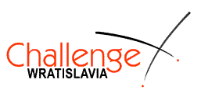
43. Challenge Wratislavia
Wrocław (Poland), 18-22.03.2021
http://www.challengewratislavia.pl/

Registration form

CLUB
ADDRESS
COUNTRY
NATIONALITY
e-mail

Participants

No | SURNAME | Name | Gender  (male or female) | Weapon  (epee, foil, sabre) | Date of birth
1.
2.
3.
4.
5.
6.
7.
8.
Referee
No | SURNAME | Name | Weapon (epee, foil, sabre)
1
Coach
No | SURNAME | Name | Mobile
1.
2.

Please send this form via email to wratislavia@wroclawianie.com.pl before March 13th, 2021

Submission and participation in the Tournament are tantamount to consent to the processing of personal data and their use along with a personal image on the website of the Organizer, the Polish Fencing Association, traditional media and social media.

